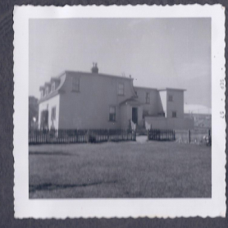

3 - The Pennywell Road house from inside the Green Gate looking west

